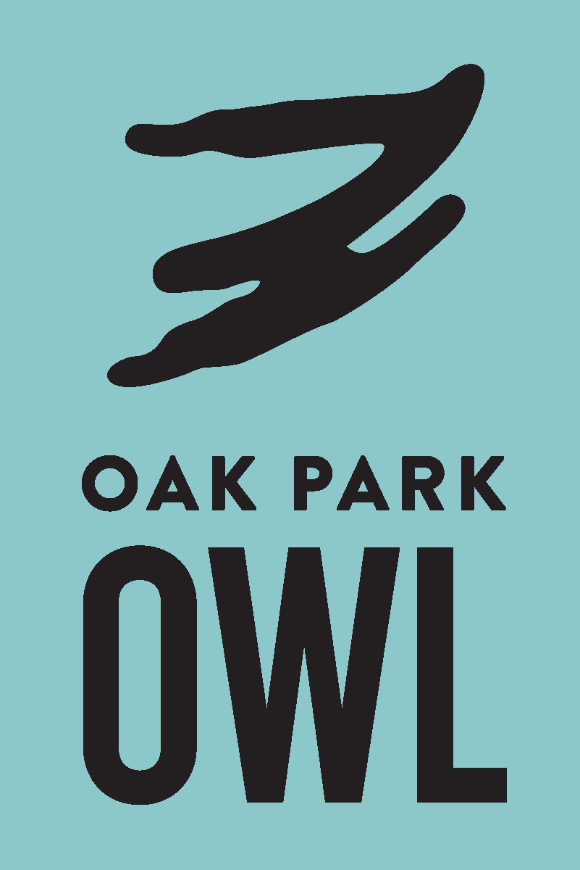
Oak Park Our Whole Lives
8th Grade Schedule Winter 2026

The class has 1 Family Information Meeting and 12 regular sessions

Family Information Meeting—Choose One. (Required, meets on Zoom)
Tuesday | 1/6 | 7:00-8:00 pm
Wednesday | 1/7 | 7:00-8:00 pm

Regular sessions (In Person):
Sunday | 1/11 - 4/26  Class Does NOT Meet 1/18, 3/15, 3/29, 4/5  Class Does Meet the Sunday before President’s Day, 2/15 | 3:00 - 5:00 pm

Session Topics
1/11 | Session 1 | Introduction to OWL
1/25 | Session 2 | Anatomy
2/1 | Session 3 | Sexual Identity
2/8 | Session 4 | Body Image and Self-Respect
2/15 | Session 5 | Puberty
2/22 | Session 6 | Dating and Communication
3/1 | Session 7 | Healthy Relationships
3/8 | Session 8 | Arousal
3/22 | Session 9 | Consent and Accountability
4/12 | Session 10 | Safer Sex
4/19 | Session 11 | Pregnancy and Parenting
4/26 | Session 12 | Sexual Decision-Making

Participants are expected to attend all sessions in order to build and maintain group trust and cohesion. We understand that the unexpected happens, but please plan to be there for every session.

